Topic : Interrupted mating technique and time of entry mapping
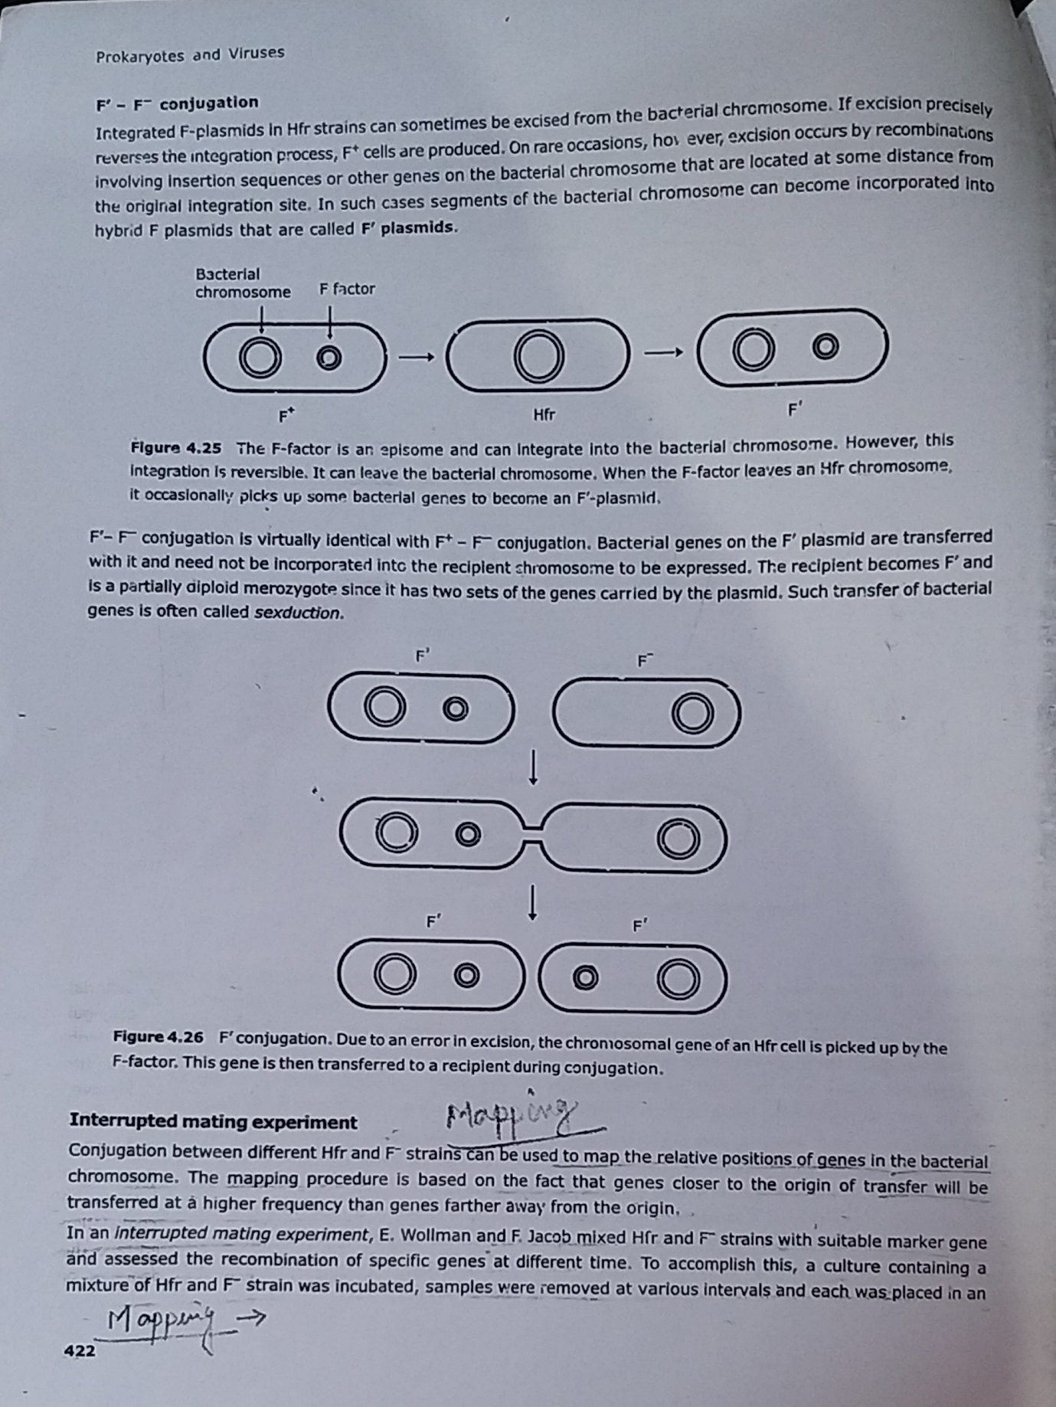

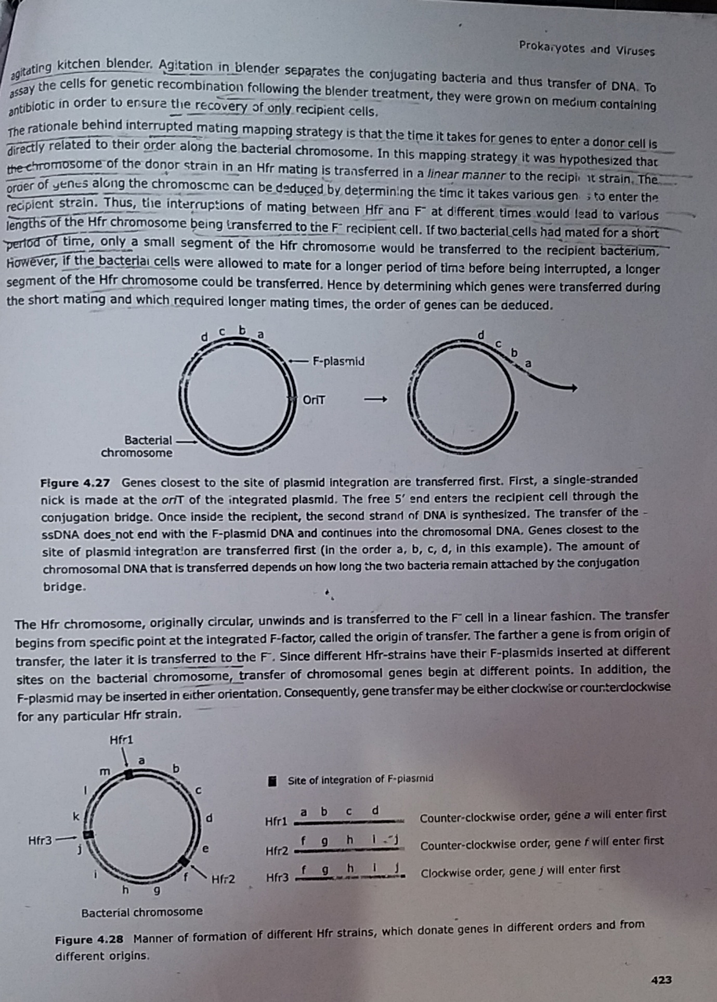

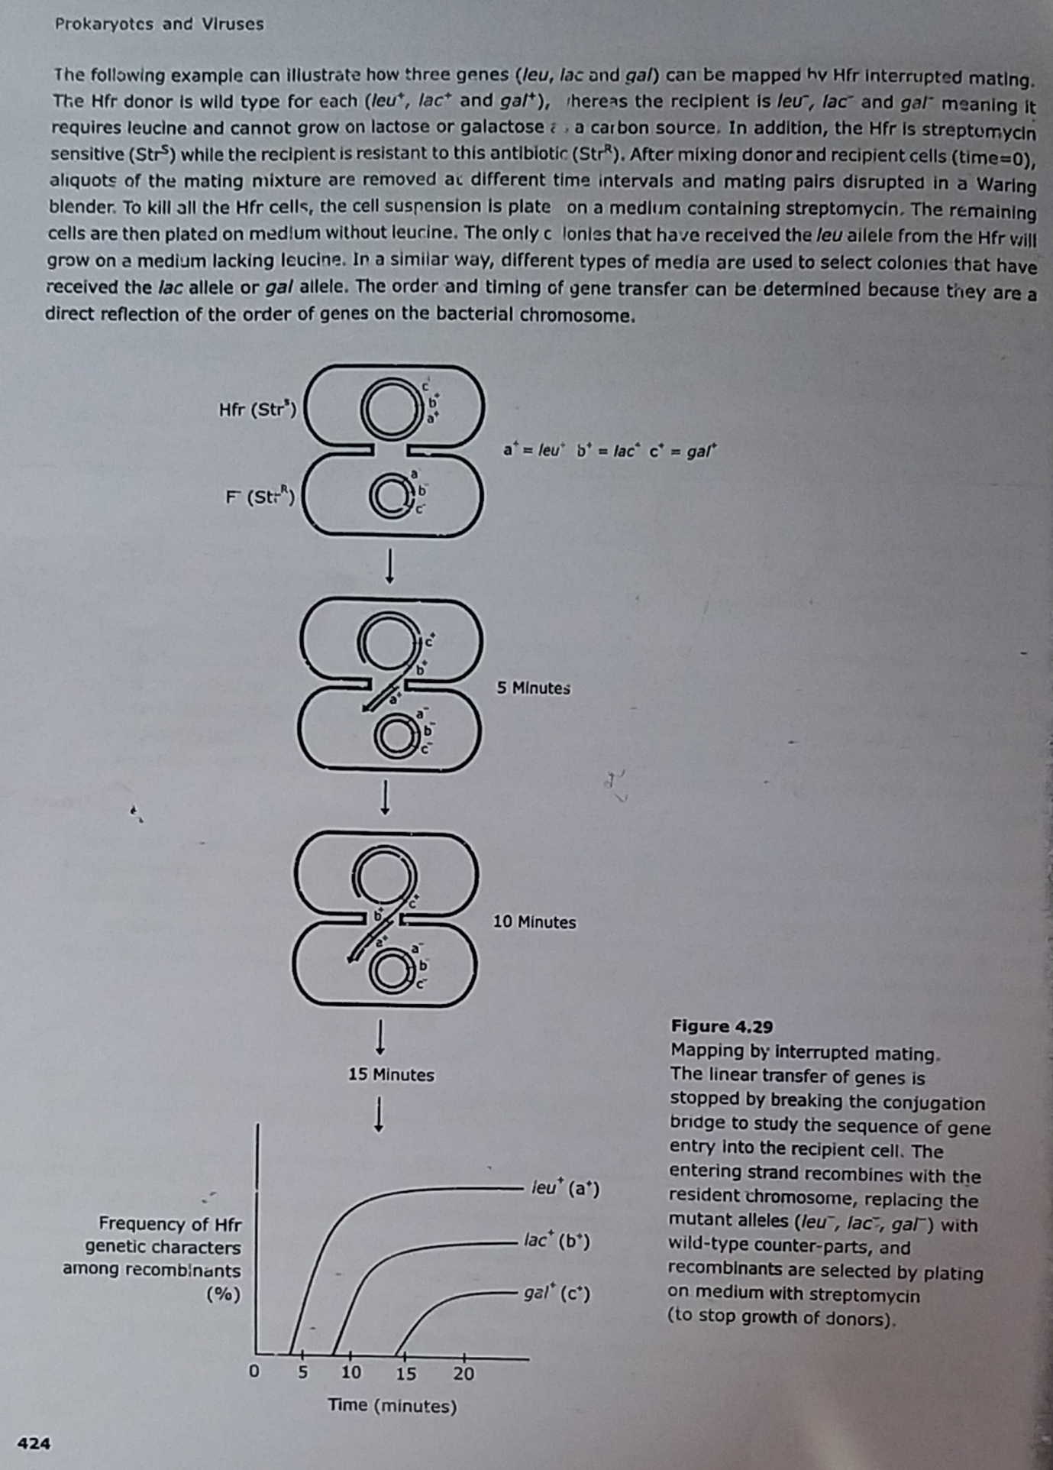References: Life Sciences-Fundamental and Practices Part -1 By Pranav Kumar and Usha Mina

